The Housing Authority of Yamhill County administers the Housing Rehabilitation Loan & Grant Programs on behalf of the Yamhill County Affordable Housing Corporation.

The programs are funded by Community Development Block Grants, the Regional Housing Rehabilitation Revolving Loan Fund, and other periodic State and Federal Grants.

The objectives of the programs are:
- To alleviate health and safety problems and correct structural deficiencies in homes.
- To make modifications to accommodate senior or disabled residents.
- To help avoid occupant displacement.
- To focus on the housing needs of the lower-income citizens of the community.
- To encourage the conservation of energy and other resources.
- To help encourage the maintenance and preservation of affordable housing in our community.
- To reduce the number of substandard housing units in need of major and minor repairs.

Area Served
All of Yamhill County including the city limits of Willamina.

The Loan Programs

To qualify applicants must:
- Have income that is within the income limits on the back of this flier
- Own their home and the land it is situated on
- Have lived in the home for the past six months
- Have equity in the home
- Have eligible repair items
- Meet all other program eligibility criteria.

Loan terms and amounts:
Qualified very low-income homeowners receive 0% loans with no payments. Qualified low-income homeowners receive 2%, twenty year term loans with no payments for 1 year.

Loan amounts range from $5,000.00 to $25,000.00 depending upon the necessary repairs, available equity, and funding.

Loans are due in full if the owner no longer lives in the home, if it is sold, if the title is transferred, or if the use of the property changes.

The Grant Program

We periodically receive funding to provide grants to people not eligible for the Loan Program because they do not own the land their homes are situated on. Grants are only provided to correct immediate health and safety issues or to make modifications necessary for disabled or elderly homeowners. Grants cannot exceed $15,000 or the actual cost of the approved repair items.

To qualify applicants must:
- Own your home but not the land that it is situated on
- Have income that is within the income limits on the back of this flier
- Have eligible repair items
- Have lived in the home for at least six months
- Meet all other program eligibility criteria

Who does the work?:
- A licensed & bonded contractor of your choice.

How Do I Apply?
If you would like your name added to the waiting list, please fill out the enclosed form and return it to the address listed below.

Housing Authority of Yamhill County’s
Housing Rehabilitation Program
135 NE Dunn Place
McMinnville, OR 97128

If you have questions regarding the Home Repair Program, please contact:

Mark Irving at (503) 883-4324
Or e-mail: mirving@hayc.org
Or visit our website: www.hayc.org

INCOME LIMITS FOR 2022

To qualify for the Loan or Grant programs applicants must have income at or below the following income limits established by HUD:

FAMILY SIZE | Income limit
 |  | Annually
1 |  | $63,150
2 |  | $72,200
3 |  | $81,200
4 |  | $90,200
5 |  | $97,450
6 |  | $104,650
7 |  | $111,850
8 |  | $119,100

Housing Authority of Yamhill County
135 NE Dunn Place
McMinnville, OR 97128

HOUSING REHABILITATION PROGRAMS:
- County Wide Revolving Loans
- Veteran’s Revolving Loans
- Manufactured Home Grants

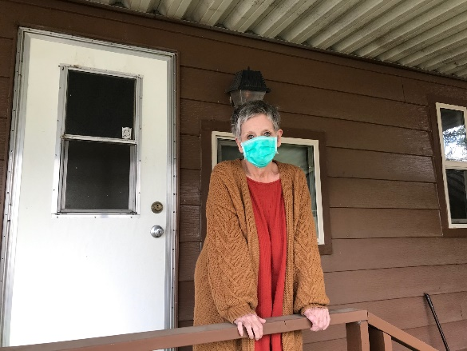

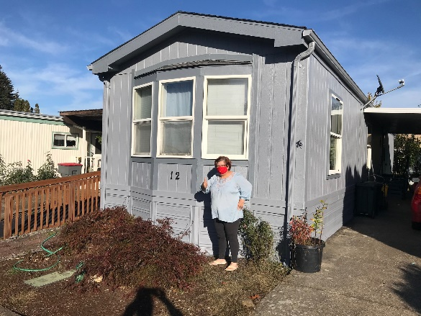

The preparation of this document was funded in part with federal funds from the Oregon Community Development Block Grant Program. This document is not subject to state or federal copyright law. As such, any part of the documents may be reprinted, copied or duplicated without the permission of the State of Oregon or the grant recipient.

